Wilify Website Documentation

Willify is a song website project that is inspired by Spotify, including its concept, design, and functionality. Here’s the description on every Element containing on this website.
This project is made using HTML, CSS, and JavaScript with Visual Studio Code.

- Logo


My logo is designed with the Play button with 2 block notes side by side on the inside to emphasize the music element and tells people that the logo belongs to a music related application.

- Navigation Bar
The navigation bar contains my Wilify logo, home button, “About Us” button, register button, and the non-functional profile button. Each of them is functional except for the profile button. All of them direct us to another html page on click based on the icon.
Logo and Home button -> home.html (home page)
About Us button -> about.html (about us page)
Register button -> login.html (register page)

The navigation bar position is made sticky to make it always stays on the top. This is done to make sure user can always navigate to another page whenever they wanted with no difficulties.

- Footer
This footer was just made for the decoration, there’s nothing really functional down here because we can’t actually play the song.

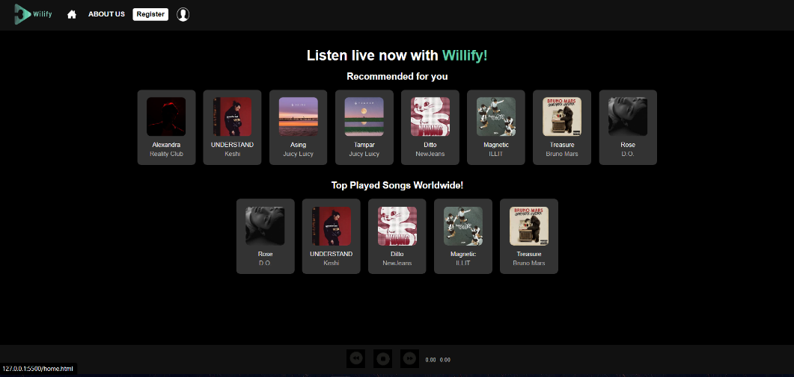
- Home page
The home page contains Recommended songs, and the Top played songs worldwide. All of the song are clickable and it’ll lead the user to -songname-.html on click. The home page is made responsive on zoom in and zoom out, all of the displayed elements will move according to the zoom percentage.
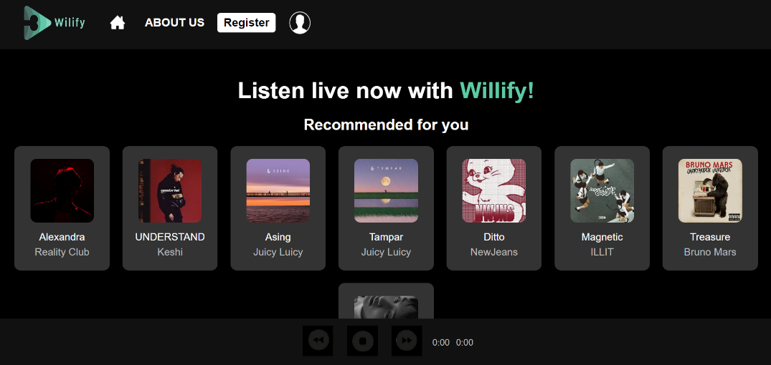
as you can see here, the layout changes when the user zooms in or out.

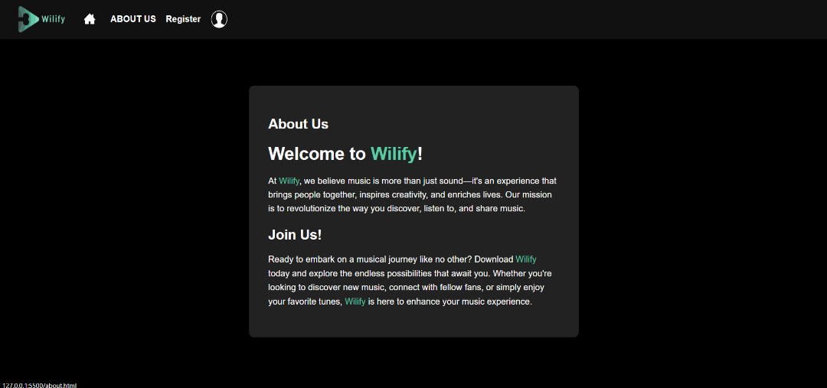
- About-Us Page
This page is pretty simple, it only contains description on why my website/app is better, missions, and persuasion for the user to download the app. As you can see this page contains no footer because I think it’ll be better without it, as the focus is the “about us” text so there’s no need for the footer.

- Register Page
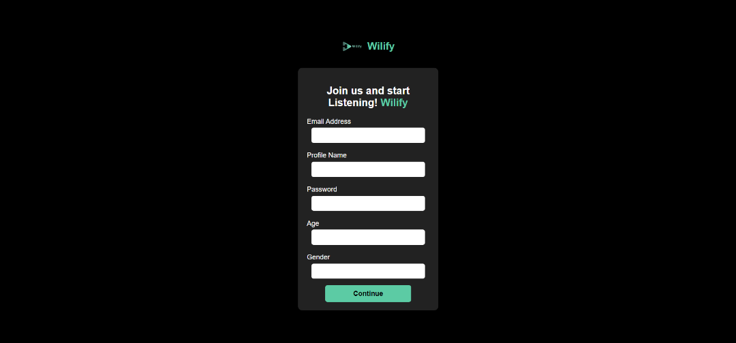
This page is for the user to register on the page. And the restriction I made is not too complicated. For the email, user need to input words that contains “.com” to ensure that user inputted an email. For the profile name, it just can’t be empty, neither the password. Age must be over 13, and gender can’t be empty. Otherwise, there’ll be an alert according to which violation the user made. If all input is valid, then there’ll be an alert saying “Registration Successful!” and direct the user to home.html (home page).

- Song Details
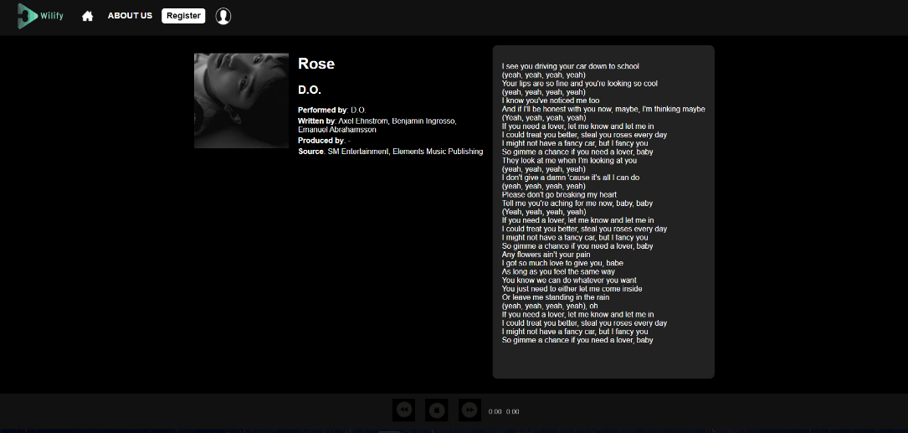
This is one of the song details pages. All of the song here has its own song details page. The song image and description are made sticky so it stays on the top below the navigation bar.

References Links:
- www.spotify.com song descriptions, lyrics, design reference
- https://youtu.be/In0nB0ABaUk?si=t3HMnmnyBuLbsS5H JavaScript validation learning
- https://youtu.be/In0nB0ABaUk?si=t3HMnmnyBuLbsS5H guides on making website using HTML and CSS.

